Software Requirements Engineering – Lab Report
Sources of Requirements + Kano Model — University Course Registration System
Group: Hudaibia, Sarah Arif, Eshaal Nazir, Abdul Samad
Submitted to: Sir Fahim Muhammad Khan Date: 24 Sept 2026

1. What we did
For this lab we had to identify requirement sources for a university course registration system and use the Kano Model to evaluate 10 candidate features. We prepared a questionnaire, collected 40 responses, and summarized the results below.

2. Sources of requirements (8)
Source | Example | What we get from it
Students | The people who will actually use the system | Needs and pain points
Registrar office | Registration staff | Rules and approvals
Faculty | Course instructors | Prerequisites and seat limits
IT staff | University IT department | Security and technical limits
Current system | Manual process | Existing strengths and weaknesses
Academic policies | University rules | Mandatory constraints
Watching students register | Observation | Real registration problems
Survey | Kano questionnaire | Student preferences

3. Candidate features (10)
No. | Feature
1 | Search courses by code/title/department
2 | Show remaining seats
3 | Registration confirmation
4 | SMS/email notification
5 | Automatic course recommendations
6 | Dark mode
7 | Download timetable as PDF
8 | Remember selected courses
9 | Save data if network drops
10 | Fast response at peak times

4. The Kano questionnaire
Each feature had two questions (functional and dysfunctional) with five response options: Like, Expect, Neutral, Tolerate, and Dislike.

5. How we classified answers
Have \ Don't | Like | Expect | Neutral | Tolerate | Dislike
Like | Q | A | A | A | O
Expect | R | I | I | I | M
Neutral | R | I | I | I | M
Tolerate | R | I | I | I | M
Dislike | R | R | R | R | Q

6. Results (n = 40)
Feature | A | O | M | I | R | Q | Dominant
Course search | 15 | 11 | 1 | 8 | 0 | 4 | Attractive
Seat display | 12 | 9 | 4 | 9 | 0 | 4 | Attractive
Registration confirmation | 5 | 12 | 5 | 10 | 2 | 4 | One-dimensional
SMS/email notification | 9 | 9 | 2 | 13 | 1 | 4 | Indifferent
Course recommendations | 8 | 8 | 1 | 12 | 3 | 4 | Indifferent
Dark mode | 6 | 8 | 1 | 13 | 5 | 6 | Indifferent
Download timetable | 8 | 11 | 5 | 7 | 1 | 6 | One-dimensional
Remember courses | 9 | 8 | 3 | 10 | 3 | 4 | Indifferent
Data preservation | 5 | 8 | 3 | 10 | 3 | 8 | Indifferent
Fast peak response | 7 | 12 | 5 | 9 | 1 | 5 | One-dimensional
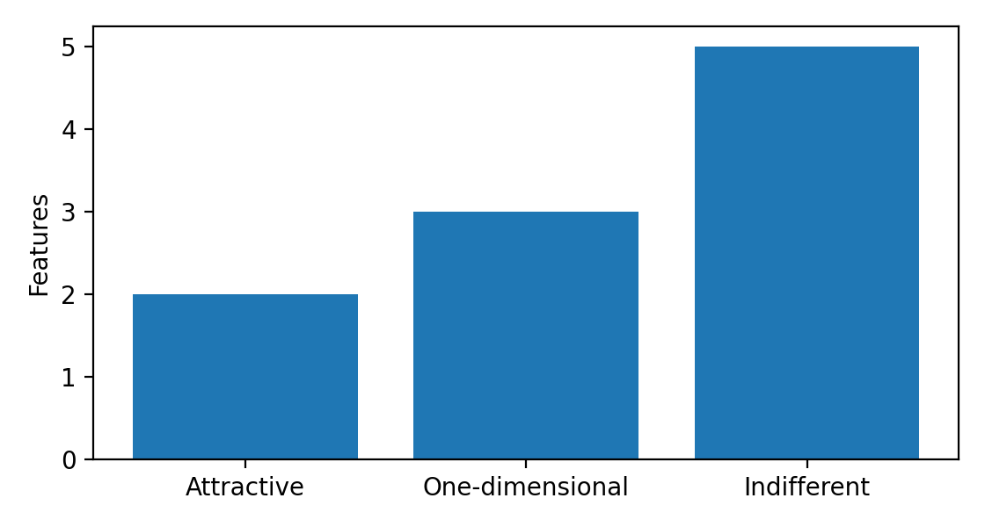

7. What the results mean
Course search and seat display were Attractive. Registration confirmation, timetable download, and peak-time performance were One-dimensional. Notifications, recommendations, dark mode, remembering courses, and data preservation were mostly Indifferent.

8. Does this decide what we build first?
No. Kano reflects user perception, but implementation order should also consider cost, effort, and dependencies.

9. Who did what
Name | Worked on
Hudaibia | Requirement sources + feature list
Sarah Arif | Questionnaire + Google Form
Eshaal Nazir | Spreadsheet + classification + chart
Abdul Samad | Write-up + reflection + final report

